

NEWS MAVENS



**Submitted By**:

Usama Shafique

(F-201054)

Rameen Naveed

(F-201043)

Asjad Ullah

(F-201016)

**Supervisor:**

**Engr** Fahim Muhammad Khan

**SE Cordinator**

DEPARTMENT OF SOFTWARE ENGINEERING

ARMY PUBLIC COLLEGE OF MANAGEMENT AND SCIENCES

AFFILIATED WITH THE UNIVERSITY OF ENGINEERING AND TECHNOLOGY

TAXILA

December13,2022News Mavens

A thesis submitted in partial fulfillment of the requirements for the degree of

B.Sc. Software Engineering

**Authors**

Usama Shafique (F-201054)

Rameen Naveed (F-201043)

Asjad Ullah (F-201016)

**____________________________________**

**Supervised by**

**Engr** Fahim Muhammad Khan

**SE Cordinator**

_________________________

Head of Department

Dr. Huma Hayyat Khan

DEPARTMENT OF SOFTWARE ENGINEERING

ARMY PUBLIC COLLEGE OF MANAGEMENT AND SCIENCES

**December16,2022**

**ACKNOWLEDGEMENT**

In the name of Allah, the most gracious and merciful, we thank Allah and give all praise to Allah for guiding us and giving us the strength to continue and finish, to submit the report on time, and without whose assistance this study, which required untiring effort, would not have been possible to complete within the time limit. On this special occasion, we would like to thank our supervisor, Engr.Fahim Muhammad khan for her supervision and inspiration throughout our final year project. Next, our thanks go to our parents that helped in various ways to ensure we can complete our project whether in moral support and financial support.

**UNDERTAKING**

This is to declare that the project titled “Title of your FYP” is an original work done by the undersigned, in partial fulfillment of the requirements for the degree “B.Sc. Software Engineering” at Software Engineering Department, Army Public College of Management and Sciences, affiliated with UET Taxila, Pakistan. The work has not been presented elsewhere for assessment. Where material has been used from other sources, it has been properly acknowledged/referred.

Usama Shafique (F-201054)

Rameen Naveed (F-201043)

Asjad Ullah (F-201016)

**CERTIFICATE**

This is to certify that the project titled “News Mavens” is the bonafide work carried out by Usama Shafique,Rameen Naveed,Asjad Ullah, students of BSc. Software Engineering, of Army Public College of Management and Sciences, affiliated with UET Taxila during the academic year 2018-2021, in partial fulfillment of the requirements for the award of the degree of BSc. Software Engineering and the project has not formed the basis for the award previously of any other degree, diploma, fellowship, or any other similar title.

Date: Signature of the Supervisor

December16,2022

**ABSTRACT**

**News Mavens**

News Mavens will be the platform for everyone to stay up to date on daily news reports, and a large community of journalists can take advantage of our platform by sharing their news in various forms and writing blogs to build their profile, and as their news trended, they will be paid (via CPV, CPM) for it.Many large companies or media houses will be able to hire journalists on a remote basis through our platform (small projects, contract basis). It will also assist large media organizations in providing the remote journalists they require based on the journalist's profile. It will save them time from going through the lengthy process of hiring the right person in their area.They can hire an expert from any region and work with him remotely using News Mavens. It will provide them with a large network of journalists from which to choose. Our platform will provide a good communication channel, payment security, and protection for both the work of journalists and the projects of buyers. The media companies can also post jobs on News Mavens for journalists to bid on.

**Keywords:**

* News mavens
* journalists
* Media houses**LIST OF FIGURES**

1. Buyer Flow diagram 5

2.Journalist Flow diagram 5

3.Viewer Flow diagram 6

4.Use case diagram of user 6

5.Use case diagram of admin 6

6.use case diagram of company.................................................................................................7

7.use case diagram of journalist.................................................................................................7

8:use case diagram of News Mavens.........................................................................................8

9.ER diagram 15

10.Class diagram 17

10.1 Relationship of company and administrator............................................................................18

10.2.Relationship of Journalist and Applicant.................................................................................18

10.3.Relationship of News and Viewer...........................................................................................19

104.Relationship of New and Journalist..........................................................................................19

11.Figures of prototype 20

11.1Started page..................................................................................................................20

11.2Login page...................................................................................................................21

11.3 Select account for resgitration....................................................................................21

11.4Viewer registration page..............................................................................................22

11.5 Buyer registration page...............................................................................................22

11.6 Journalist registration page.........................................................................................23

11.7 Journalist dashboard page...........................................................................................23

11.8Viewer dashboard page................................................................................................24

11.9Buyer dashboard page..................................................................................................24

12.Figures of UI design 25

12.1Home page...................................................................................................................25

12.2Home page...................................................................................................................26

12.3Home page...................................................................................................................26

12.4Service page.................................................................................................................26

12.5 Registration page........................................................................................................27

12.6 Login page..................................................................................................................27

**LIST OF TABLES**

1. Comparison of existing systems and our system. 3

**Table of Contents**

1. Introduction 1

1.1. Problem Statement 1

1.2. Aim and Objectives 1

1.3. Application/Utilization of project 1

2. Literature Review 2

2.1. Background Knowledge 3

2.2. Existing System/comparison 3

3. Methodology 3

3.1. Detailed Methodology with block and flow diagrams 5

3.2. Project time-line 18

3.3. Experimental/ Simulation Setup 19

3.4. Details of Work packages completed/milestones achieved 19

4. Result and Discussion 20

4.1. Evaluation parameters.............................................................................................................20

4.2.Simulation Result 20

4.3.Product Demo/ScreenShot ....20

4.4.Result discusson

1. **Introduction:**

Many news organization need journalists for one-time projects but must hire them because there is no proper channel for hiring journalists for one-time projects remotely or on-site[1].

Nowadays, people rely on unauthenticated social media news that lacks a credible source. [5]

Job security is one of the most difficult aspects of our country these days (journalist). [6]

News Mavens will be the best platform for everyone to keep themself up to date about daily news reports and a vast community of journalists can take huge advantage of our platform as they can share their news in many forms and write blogs to make their profile strong and as their news goes on trending they will be paid (using CPV, CPM) for it. Our platform will provide remote work for journalists as many big companies or media houses can hire them on remote basis work (small projects, contract basis). It will also help big media houses to provide them with remote journalists they need according to the profile of journalists.

**1.1 Problem statement:**

* Job security is one of the most difficult aspects of our country (journalist) these days.[6]
* People nowadays rely on unauthenticated social media news that lacks a reliable source.[5]
* Also, because of the market gap, media companies are unable to find the right person.[1]
* Many news organizations require journalists for single projects but must hire them because there is no proper channel for hiring journalists for single projects remotely or on-site[1].

**1.2. Aim and objectives:**

**Aim:**

To facilitate journalists,viewer’s and media houses to see/post updated jobs/new’s.

**Objectives:**

* To help journalist community to provide freelance remote work opportunities and reduce job insecurity.
* To help media houses,new channels and online newspapers companies to find the best journalist they need.
* To help to keep everyone up to date with daily news about news reports by providing an authentic and resourceful news.

**1.3. Application/utilization of research:**

The work done on mobile journalism and digitalized journalism, we concluded our idea that news mavens can fill the gap left in them. As we know everything is almost getting digitalized and has strong existence on the internet so we thought why not a platform for journalists which can help them do their job from anywhere, a platform to help media organizations, and news agencies to get news reports from a remote journalist from a place where they cannot send their person immediately. Also, our platform will help users to get every kind of news just a single tap away in form of a mobile app on their phones. Also, we have noticed the communication and wages gap in the news industry our platform will make sure to provide both ends journalists, news agencies and organization to have a better and modernized way of communication through our platform so they can end on better terms for their tasks or projects.

1. **Literature Review/Background knowledge:**

When viewed historically, modern citizens have incomparable opportunity to receive and participate in news reporting.[1]

The main goal of the MoJo(Mobile Journalist )MATE platform is to improve the quality of mojo stories and implement the complete workflow of a newsroom, working within this framework is expected to improve users’ new media capabilities.[2]

The app must be integrated sufficiently in a broader social media strategy. In other words, the innovation must supported by every stakeholder of the regional news station.There must be invested in a platform, in an embedding in the editorial structure of the regional news broadcaster and in interaction between the broadcaster and the youngster. Young people want to know what will happen to the content they deliver through the mobile reporting application. Additionally, an incentive policy can be set up to motivate users submitting news items repeatedly[3].

In the phases of economic downturn, working journalists have always been affected by downsizing, termination, and layoff and cut in salaries as well as job- related issues which are heighting job related concerns in journalists working in the media industry. [4]

Many have expressed concern about the effects of false stories ("fake news"), circulated largely through social media. [5]

From a historical perspective, contemporary citizens have gained incomparable opportunities to access and contribute to news reporting. [6]

The work done on mobile journalism and digitalized journalism, Fake stories on social media to mislead people.Just awareness about fake news issues and no proper solution to stop people from sharing or posting fake news

we concluded our idea that news mavens can fill the gap left in them. As we know everything is almost getting digitalized and has strong existence on the internet so we thought why not a platform for journalists which can help them do their job from anywhere, a platform to help media organizations, and news agencies to get news reports from a remote journalist from a place where they cannot send their person immediately. Also, our platform will help users to get every kind of news just a single tap away in form of a mobile app on their phones. Also, we have noticed the communication and wages gap in the news industry our platform will make sure to provide both ends journalists, news agencies and organization to have a better and modernized way of communication through our platform .

**2.2 Existing System/Comparison:**

* JournalismJobs.com is only job posting website with just“apply for” link doesn't have a suitable platform for journalist and new industry organization.
* Contena is limited to just one service that they provide to new industry which is writing.
* Upwork is not specially for journalist and commonly use by writer.

Our platform we offer will give journalist access to regular employment prospects in the form of long term project .Opportunities and lowering journalist job insecurity.Our platform enables media companies and news agencies to receive news reports from distant journalist in location they are enable to send staff member right a way.Our technology enable viewer to get all types of news through via mobile app .

The table below is comparison between existing systems and our system.

|  |  |  |  |
| --- | --- | --- | --- |
| Existing System | Remote | Specialized Platform | Daily Vast News Update |
| Contena | ✓ | X | X |
| JournalismJobs.com | ✓ | X | X |
| Upwork | X | X | X |
| News Mavens | ✓ | ✓ | ✓ |

Table1.comparison of existing systems and our system.

1. **fConcept:d**

In the first phase of Agile Methodology we will determine [the scope our project](https://www.wrike.com/project-management-guide/faq/what-is-scope-in-project-management/" \t "C:\\Users\\DELL\\Desktop\\NewsMavens\\First%20Proposal%20&amp;%20Prsentation%20FYP\_blank). We will discuss key requirements with Journalists and news industries organizations and prepare documentation to outline them, including what features will be supported and proposed end results. At this stage we will also estimate the time and cost of our projects. This detailed analysis will help us to decide whether or not a project is feasible before commencing work.

1. **Inception:**

We will start the design process and create a mock-up of the user interface and build the NEWS mavens architecture. This stage involves further input from Journalists to fully flesh out the requirements on a diagram and determine the functionality of our application. Regular check-ins will help us to ensure that all requirements are built into the design process.

1. **Iteration:**

Next up is [the iteration phase](https://www.wrike.com/agile-guide/faq/what-is-agile-iteration/" \t "C:\\Users\\DELL\\Desktop\\NewsMavens\\First%20Proposal%20&amp;%20Prsentation%20FYP\_blank), also referred to as construction. It tends to be the longest phase as the bulk of the work is carried out here. We will work on UX design to combine all requirements of our freelance platform and all users feedback, turning the design into code. Our goal is to build the bare functionality of the project by the end of the first iteration or sprint. Additional features and tweaks can be added in later iterations. This stage is a cornerstone of Agile software development, enabling us to create working software quickly and make improvements to satisfy the user.

1. **Release:**

The product is almost ready for release. But first, we need to ensure  [quality assurance](https://www.wrike.com/project-management-guide/faq/what-is-quality-in-project-management/" \t "C:\\Users\\DELL\\Desktop\\NewsMavens\\First%20Proposal%20&amp;%20Prsentation%20FYP\_blank)  to perform some tests to ensure the project is fully functional. We will perform system testing before releasing to ensure the entire functionally/non functionality of the system/project.

1. **Maintenance/Management:**

The software will now be fully deployed and made available to users. This action moves it into the maintenance phase. During this phase, we will provide ongoing support to keep the system running smoothly and resolve any new bugs. Over time, new iterations can take place to refresh the existing application with upgrades and additional features.

**3.1 Detailed Methodology with flow diagram:**

**3.1.1. Flow diagram:**

1. **Buyer Flow diagram:**

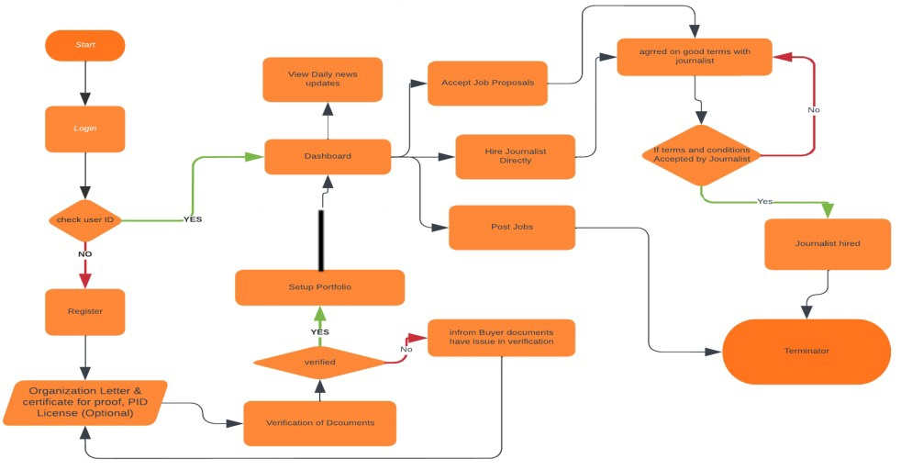

Fig1:buyer flow diagram.

1. **Journalist Flow diagram:**

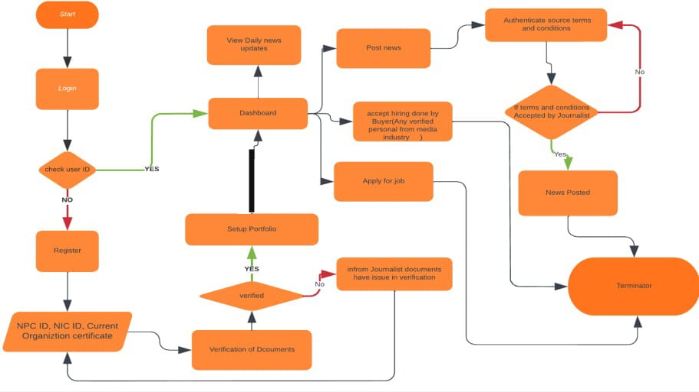

Fig2:journalist flow diagram.

1. **Viewer Flow diagram:**

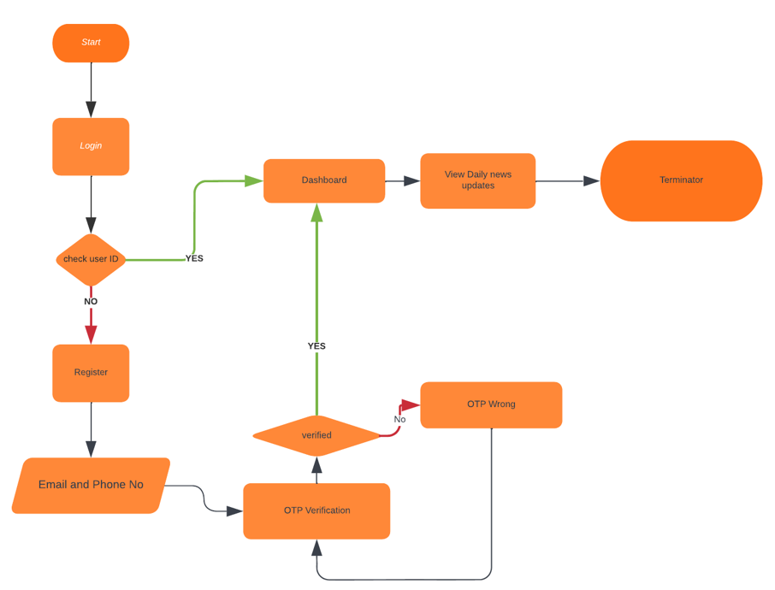

Fig3:viewer flow diagram.

**3.1.2. Use-case Diagrams:**

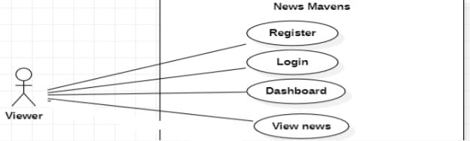

Fig4:use case diagram of viewer.

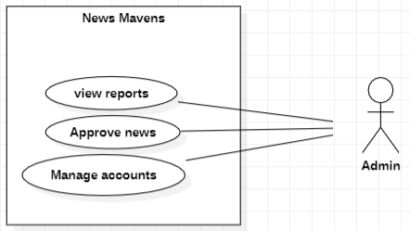

Fig5:use case diagram of Admin.

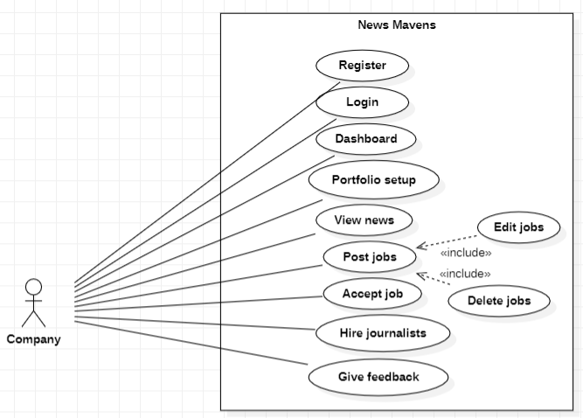

Fig6:use case diagram of company.

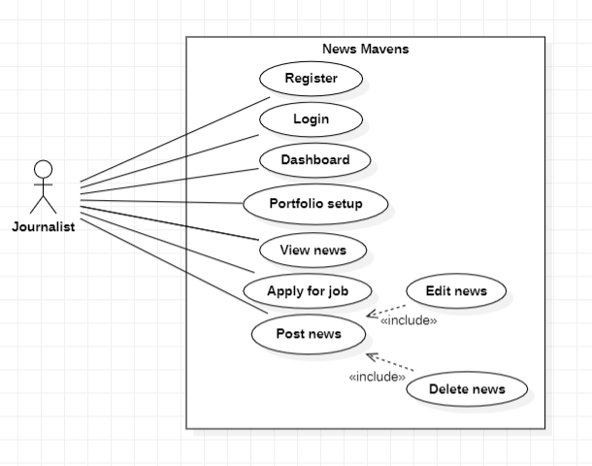

Fig7:use case diagram of journalist.

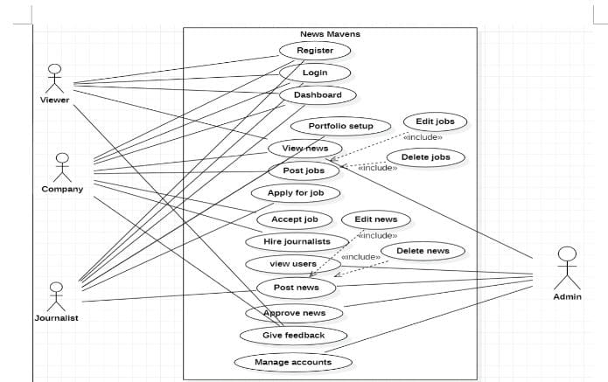

Fig8:use case diagram of News Mavens

1. **Register:**

**Description:**

Users (viewer,journalist,company) register the account by entering the name,email and password.

**Actors:**

Viewer,Journalist,Company.

**Pre condition:**

The users create the account.

**Post condition:**

The users account has been created.

**Basic flow:**

* The user (viewer,journalist,company) enters the name, email and password.
* The user(viewer,journalist,company) submits the name, email and password.
* The system register the name, email and password.
* The use case end.

**Alternative Flow**: (missing user name,email and password)

* The system prompts for user name,email and password.
* Use case resumes at basic(main)flow step 1

(maximum 3 attempts exceeded)

* The system displays “maximum attempts exceeded” message
* The system lock user account
* The use case ends

(invalid user email)

* The system displays “ invalid user email “ message
* The system prompts for user email.
* Use case resumes at basic flow step 1.

1. **Login:**

**Description:**

Users login the account by entering the email and password.

**Actors:**

Viewer,Journalist,Company.

**Pre condition:**

The user login the account.

**Post condition:**

The user account has been login .

**Basic flow:**

* The user (viewer,journalist,media house) enters the email and password.
* The user(viewer,journalist,media house) submits the email and password.
* The system register email and password.
* The use case end.

**Alternative Flow**: (missing user email and password)

* The system prompts for user email and password.
* Use case resumes at basic(main)flow step 2

(maximum 3 attempts exceeded)

* The system displays “maximum attempts exceeded” message
* The system lock user account
* The use case ends

(invalid user email,password)

* The system displays “ invalid user email or password“ message
* The system prompts for user email and password
* Use case resumes at basic flow step 2

1. **Dashboard:**

**Description:**

User login the account by entering the name,email and password.And open the dashboard.

**Actors:**

Viewer,Journalist,Company.

**Pre condition:**

The user open the dashboard.

**Post condition:**

The user select either he is journalist,viewer or company.Then open the portfolio accordingly.

**Basic flow:**

* The user Login their account.
* The system enter user into dashboard.
* The use case end.

**Alternative Flow**: (missing user email and password)

* The system prompts for user email and password.
* Use case resumes at basic(main)flow step 3.

(invalid user email and password)

* The system displays “ invalid user email and password “ message
* The system prompts for user account.
* Use case resumes at basic flow step 3.

1. **Set portfolio:**

**Description:**

User login the account by entering the name,email and password.And open the dashboard.

**Actors:**

Journalist.

**Pre condition:**

The user open the portfolio.

**Post condition:**

The journalist open.Then open the portfolio accordingly.

**Basic flow:**

* The user open the portfolio.
* The use case end.

**Alternative Flow**: (user already exists in the portfolio )

* The system display an error message. “you already exists”Use case resumes at basic(main)flow step 4.

1. **View news:**

**Description:**

User open the dashboard.User view the news.

**Actors:**

Viewer,Journalis,Company.

**Pre condition:**

The user open the dashboard of news.

**Post condition:**

The user view the news

**Basic flow:**

* The user open the dashboard of news.
* The user view the news.
* The use case end.

**Alternative Flow**: (user open the another dashboard )

* The system display an error message. “you open another dashboard”.
* The system prompts for view news .
* Use case resumes at basic(main)flow step 5.

(user already exists in the View news)

* The system display an error message. “you already exist”
* The system prompts for view news .
* Use case resumes at basic(main)flow step 5

1. **Post job:**

**Description:**

Members of media houses upload different category of journalist jobs on dashboard of job proposals.

**Actors:**

Company.

**Pre condition:**

The user open the dashboard of job proposal.

**Post condition:**

The user post jobs.

**Basic flow:**

* The company open the dashboard of job proposal.
* The company upload jobs.
* The use case end.

**Alternative Flow**: (user open the another dashboard )

* The system display an error message. “you open another dashboard”.
* The system prompts for post jobs .
* Use case resumes at basic(main)flow step 6

(user already exists in the View news)

* The system display an error message. “you already exists”
* The system prompts for post job.
* Use case resumes at basic(main)flow step 6.

1. **Apply for job:**

**Description:**

User apply for job those are posted by Company.

**Actors:**

Company

**Pre condition:**

The journalists accept job proposal of company.

**Post condition:**

The journalist sign contract provided by company.

**Basic flow:**

* The journalist accept the job posted by company
* The journalist sign the contract that company provide.
* The use case end.

**Alternative Flow**: (Already user exists on required system )

* The system prompts for apply for jobs .
* Use case resumes at basic(main)flow step 7

1. **Hire journalist:**

**Description:**

The journalist accept job proposal that are posted by company . Company hire only those journalists who accept job proposals.

**Actors:**

Company.

**Pre condition:**

The journalists sign contract by company

**Post condition:**

The company hire journalist.

**Basic flow:**

* The journalist sign the contract that company provide.
* Term and condition are set between both parties.
* The use case end.

**Alternative Flow**: (Already user exists on required system )

* The system prompts for apply for jobs .
* Use case resumes at basic(main)flow step 7

**3.1.3. ER- Diagram:**

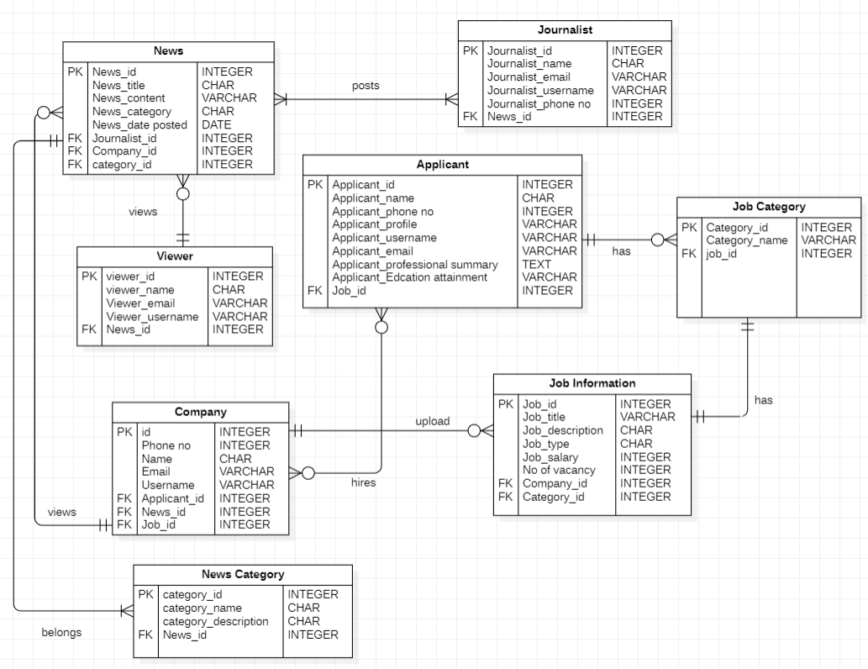

Fig9: ER diagram.

**Entities:**

* Journalist
* Viewer
* News
* Job Category
* Job Information
* Company
* Applicant

**Attributes of Entities:**

* News Entity has news_id(primary key),news title,news content,news category,news date posted, foreign key(journalists_id,company_id,category_id)
* Viewer Entity has viewer_id(primary key),viewer name,viewer email,viewer username,foreign key(news_id).
* Company Entity has company_id(primary key),company phone no, company name, company email,company username,foreign key(applicant_id,news_id,job_id).
* News category Entity has category_id(primary key),category name,category description,news_id(foreign key).
* Journalist Entity has primary key(journalist id),journalist name,journalist email,journalist username,journalist phone no,foreign key(news id).
* Applicant Entity has primary key(applicant id),applicant name,applicant phone no,applicant profile,applicant username,applicant email,applicant professional summary,applicant education attainment ,job id(foreign key).
* Job information Entity has job id(primary key),job title, job description,job type, job salary, job no of vacancy.foreign key(company id,category id).
* Job category Entity has primary key (category_id),job category name,foreign key(job id).

**Relationship:**

* Each Journalist posts one or many news .Each news is posted by one or many journalist (many to many relationship).
* Viewer views many news (1 to many relationship).
* Many company views many news(many to many).
* Many companies hires many applicants(many to many relationship).
* Company upload many job information(1 to many).
* News belongs to many news Category (1 to many relationship).
* Job information has only 1 Job Category (1 to 1 relationship).
* Journalists has many job category.(1 to many relationship).

**3.1.3. Class Diagram:**

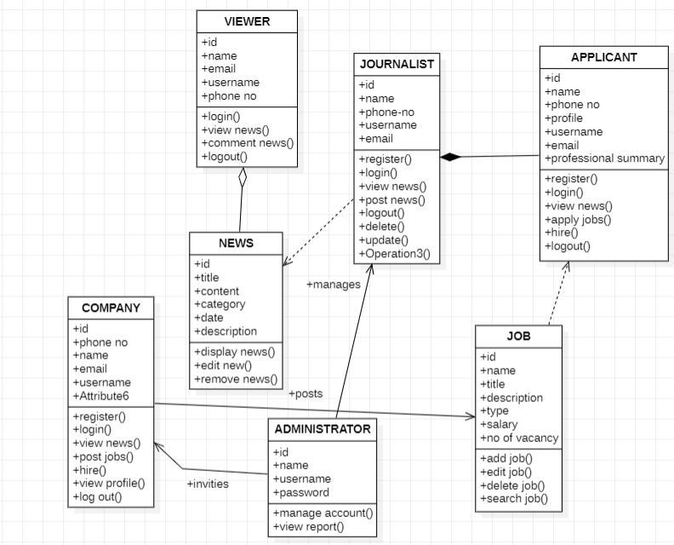

Fig10:class diagram.

**Simple Association:**

* A structural link between company and administrator.
* There is an association between between both classes.
* A solid line connecting two classes.

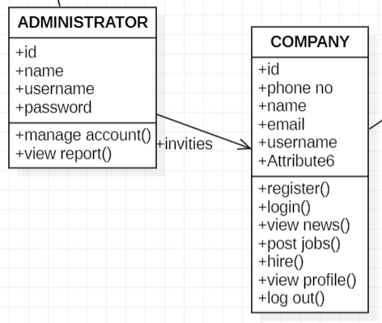

Fig10.1 Relationship of company and administrator.

**Aggregation:**

* A special type of association. It represents a "part of" relationship.
* Viewer is part of News.
* Many instances of News can be associated with Viewer.
* Objects of News and Viewer have separate lifetimes.
* A solid line with an unfilled diamond at the association end connected to the class of composite

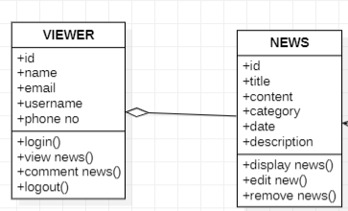

Fig10.2.Relationship of Journalist and Applicant.

* **Composition:**A special type of aggregation where parts are destroyed when the whole is destroyed.
* Objects of Applicant live and die with Journalist...
* Class Applicant cannot stand by Journalist.
* A solid line with a filled diamond at the association connected to the class of composite

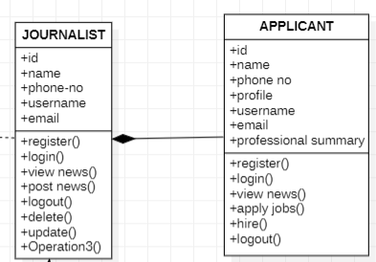

Fig.10.3.Relationship of News and Viewer.

**Dependency:**

* Exists between two classes if the changes to the definition of one may cause changes to the other (but not the other way around).
* News depends on Journalist
* A dashed line with an open arrow.

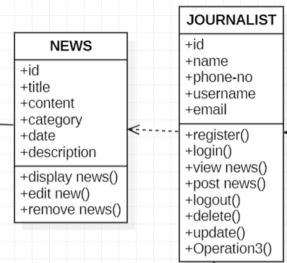

Fig.10.4.Relationship of New and Journalist.

**3. 2. Project Time-line:**

Project time-line is given below.

* Collection of literature Two Weeks
* Study of Literature Two Weeks
* Analysis of Proposed Scheme One Month
* Preparation of Scheme/Model One Month
* Implementation of Scheme/Model One Month
* Analysis and Simulation One Month
* Result Formulation Two Weeks
* Final Write-up & Thesis Submission Two Weeks

1. **3. Experimental /Simulation Setup:**

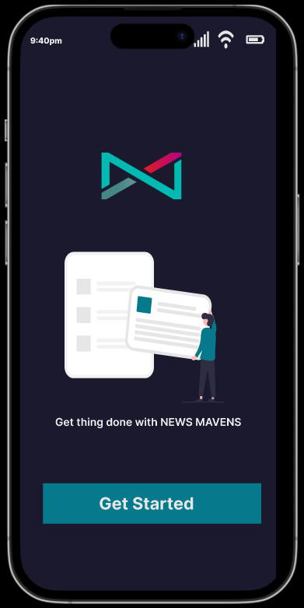

Fig.11.1Started page

This page is starting page of our system.When users open our application this screen will be display with them.

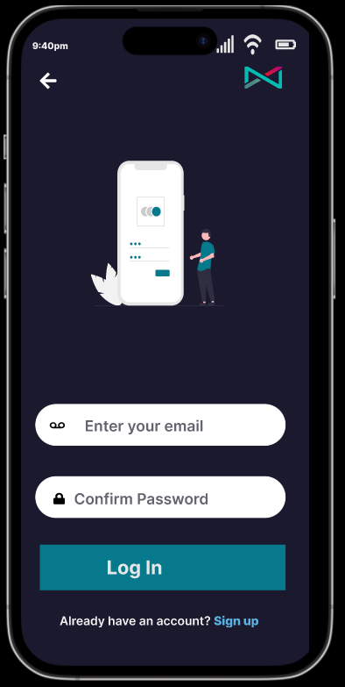

Fig.11.2 Login page

This is second page of our system.If user is already register their account then they enter their email and password and login through this page.

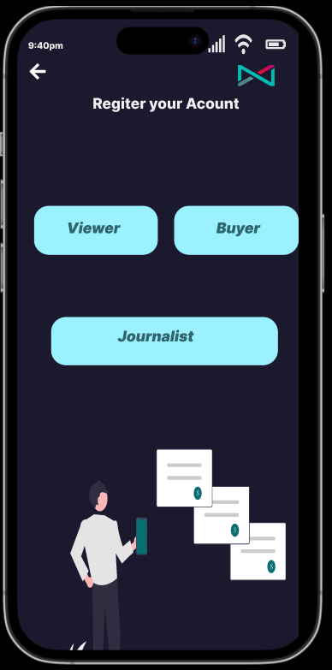

Fig.11.3 Select account for register page

If user have not register their account then this screen will appear So that users select category either he/she is viewer,journalist or member of media house.Then register accordingly.

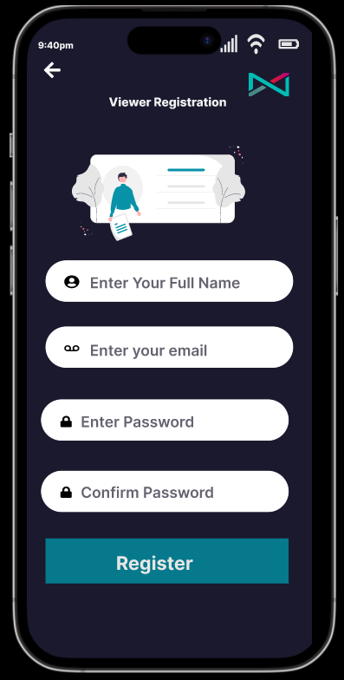

Fig.10.4 Viewer Register page

If viewer wants to register their accounts they must have full name,email,password and confirm password.

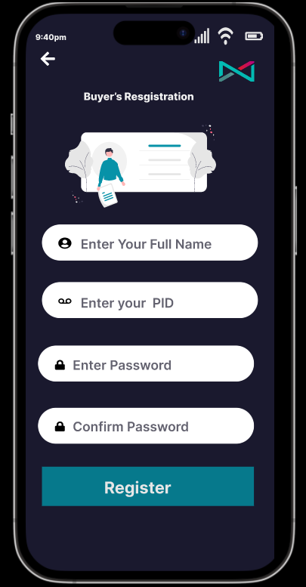

Fig.11.5 Buyer registration page

If buyer(media houses) register their account the required full name,PID no,enter password.

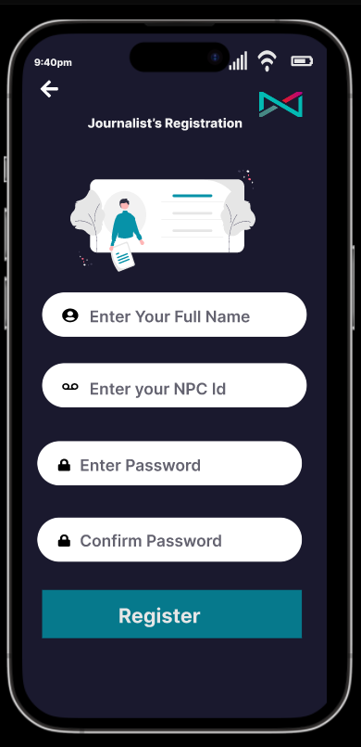

Fig.11.6 Journalist registration page

If journalist need to register their account they have to enter fill name,NPC id,enter password. And they register their account.

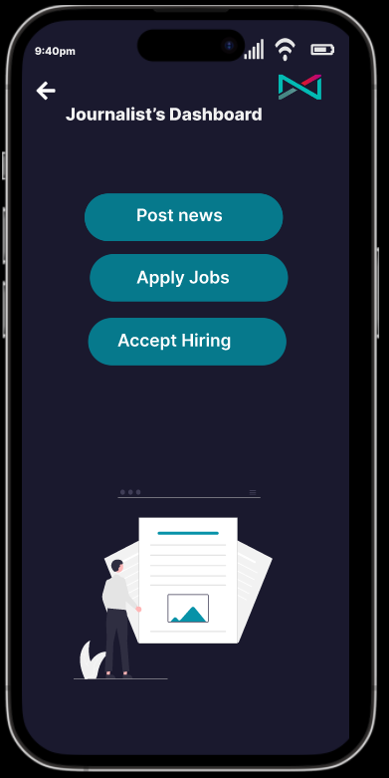

Fig.11.7 Journalist dashboard page

When journalist login their account this dashboard will appear for them .Through which they can post news,apply for jib and accept direct hiring from media houses.

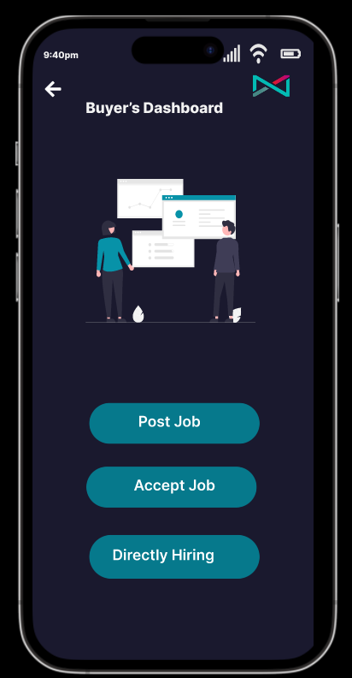

Fig.11.8 Buyer dsashboard page

When buyer login their account then they can post jobs,accept direct hiring.

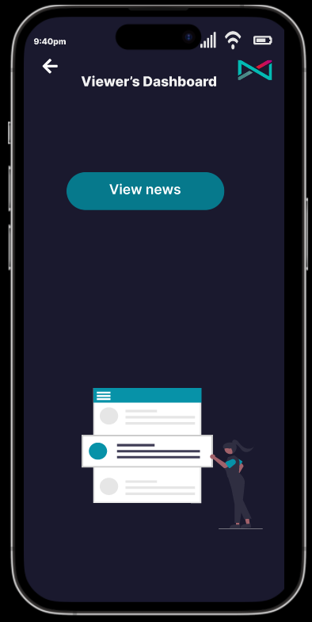

Fig.11.9 Viewer dashboard page

When viewer open their dashboard then they view news .

**3.4. Detail of work packages completed/milestone achieved:**

* Diagrams
* Prototype
* UI Design

1. **Result and Discussion:**
   1. **Evaluation parameters:**

**Appinum:**

We use appinum to test our mobile applications before they are released to the public. This is done to see if mobile applications work well across different operating systems and mobile devices.

**WebLoad:**

WebLOAD is load testing tool.We use this to check the performance of our system also check the stress of our web application. This web and mobile load testing and analysis tool is from RadView Software.

**ii)Acunetix:**

Acunetix is an automated web application security testing tool that audits our web applications by checking for vulnerabilities like SQL Injection, Cross site scripting and other exploitable vulnerabilities.

* 1. **Product Demo/ScreenShot:**

**HOME PAGE:**

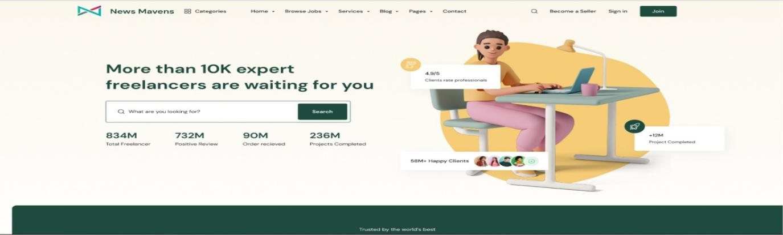

Fig.12.1 Home Page.

Home page of our website includes navigation bar, search bar for jobs, and also if someone wants to sign in so he can.

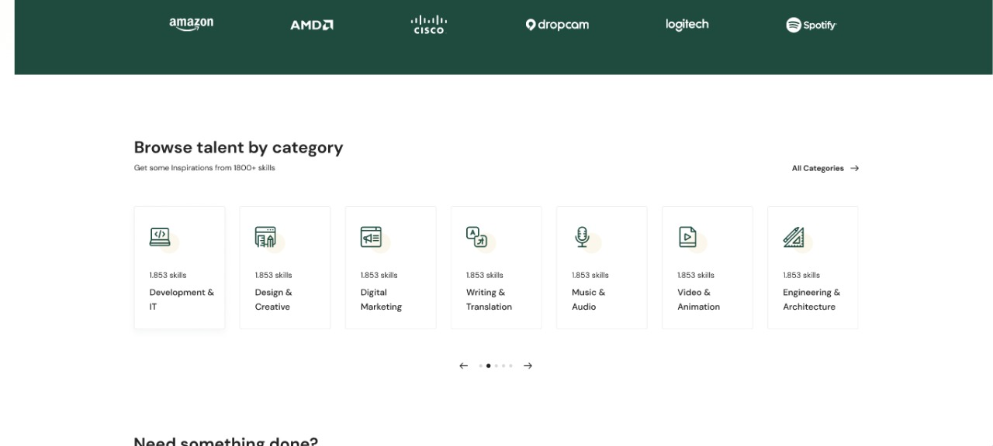

Fig.12.2 Home Page.

There are different categories of jobs for journalists.

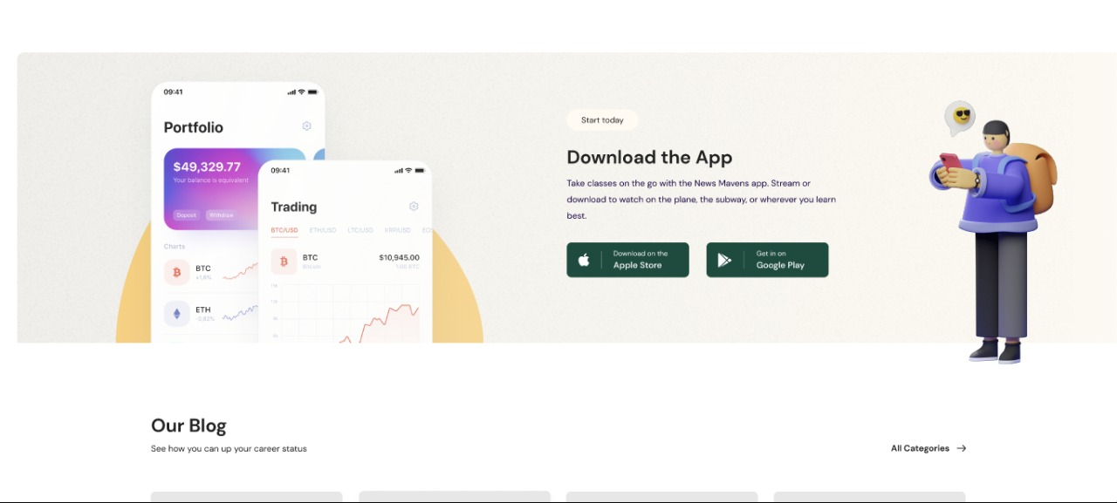

Fig.12.3 Home Page.

If user wants to download our application through our home page our website.

**SERVICE PAGE:**

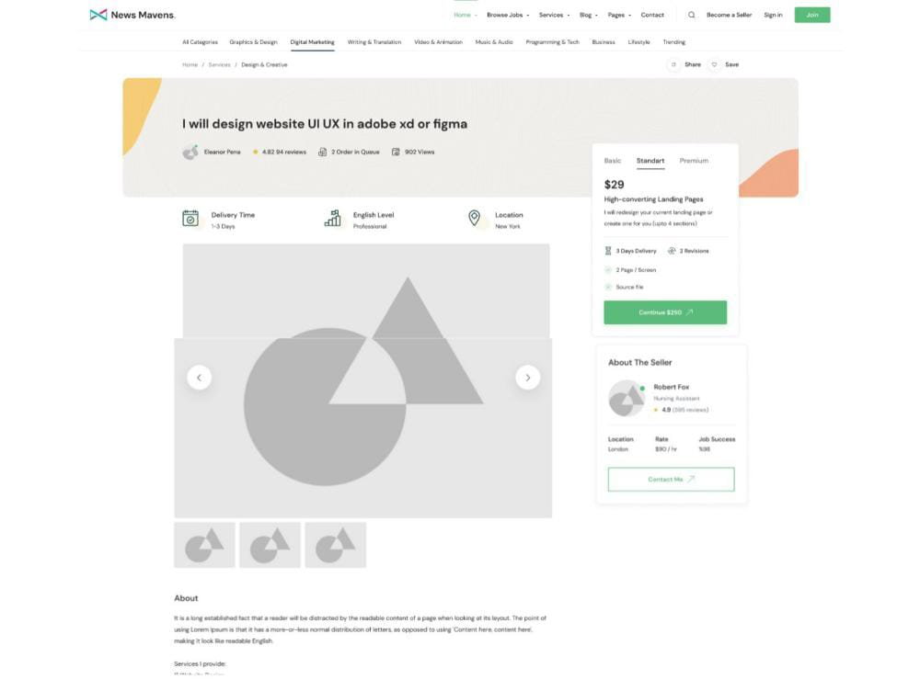

Fig.12.3 ServicePage.

The service page shows the details of the journalists jobs.the journalists present services to the media houses and motivate them to get in touch with the journalists

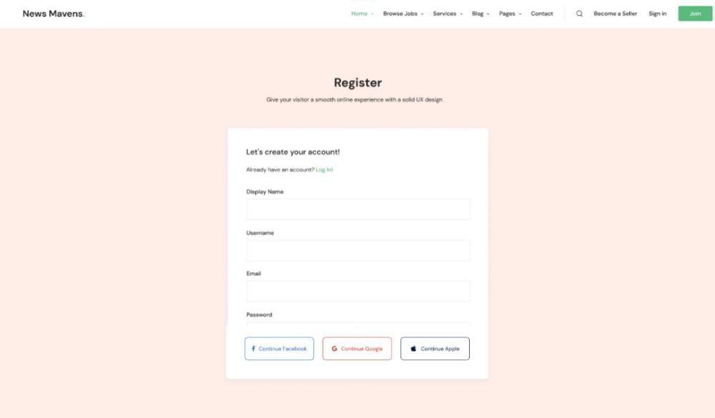

Fig.12.4 Register Page.

If someone wants to use our website first they have to register itself.

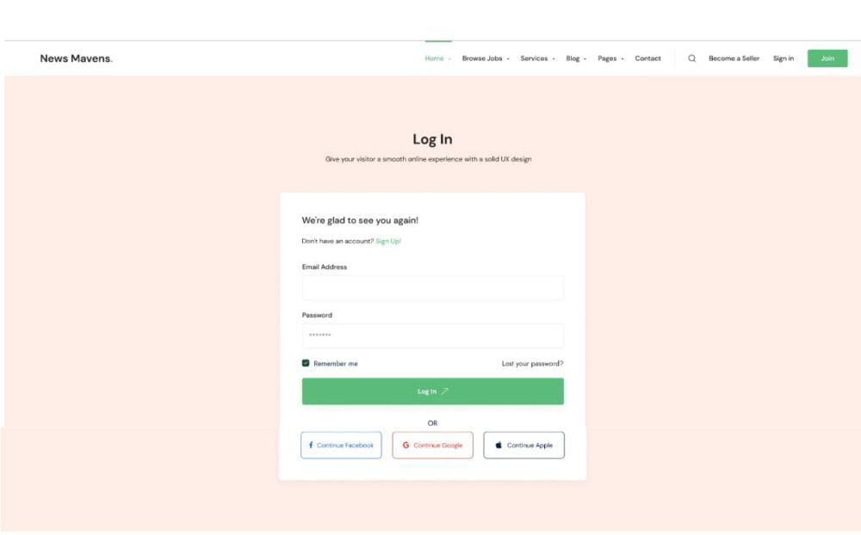

Fig.12.2 Login Page.

If someone have already account on our website they can login through email and password.

**References:**

1. Westlund, O. (2013). Mobile news: A review and model of journalism in an age of mobile media. *Digital journalism*, *1*(1), 6-26.
2. Sidiropoulos, E., Vryzas, N., Vrysis, L., Avraam, E., & Dimoulas, C. (2019). Growing media skills and know-how in situ: Technology-enhanced practices and collaborative support in mobile news-reporting. *Education Sciences*, *9*(3), 173.
3. Vandenbroucke, K., Baccarne, B., & Schuurman, D. (2014). Connecting with citizen journalists: an exploratory Living lab study on motivations for using mobile reporting applications. In *Etmaal van de communicatiewetenschappen, Proceedings*. Wageningen, The Netherlands.
4. Ashraf, A., Tayyib, M., Awais, M., & Ali, F. (2020). Effects of job insecurity on media professionals of Pakistan. Journal of Organizational Culture, Communications and Conflict, 24, 1-15.
5. Westlund, O. (2013). Mobile news: A review and model of journalism in an age of mobile media. Digital journalism, 1(1), 6-26. 3.
6. Allcott, H., & Gentzkow, M. (2017). Social media and fake news in the 2016 election. Journal of economic perspectives, 31(2), 211-36.